**HEALTH INSURANCE COST PREDICTION USING WATSON AI:**

1INTRODUCTION

1.1 Overview

1.2 Purpose

2LITERATURE SURVEY

2.1 Existing problem

2.2 Proposed solution

3THEORITICAL ANALYSIS

3.1 Block diagram

3.2 Hardware / Software designing

4 EXPERIMENTAL INVESTIGATIONS

5 FLOWCHART

6 RESULT

7 ADVANTAGES & DISADVANTAGES

8 APPLICATIONS

9 CONCLUSION

10FUTURE SCOPE

`11BIBILOGRAPHY

**1.INTRODUCTION:**

**Problem statement:** Health insurance cost prediction.

* **Overview:**

It is a platform choosen for predictive modeling and analysis. Here we provide the organisation with a machine learning model which simplifies the work of the company in various aspects.

* **Purpose:**

To build a machine learning model that helps the health insurance companies to provide premium offers to the customers based on certain factors and statistics.

**2.LITERATURE SURVEY:**

* **Existing Problem:**

Health insurance companies face a problem in determining the premium insurances for their customers. They need a trained model which predicts what kind of service is suitable to which customer. The companies should also follow certain rules set by the health care law in that country. Inorder to determine premium offers the companies have to consider certain factors and also go statistically to give importance to a customer.

* **Proposed Solution:**

The main moto of the project is to provide the health insurance companies with a machine learning model using the IBM WATSON AI platform that can predict the customer's eligibilty for different premium insurance services based on certain factors like age, gender, BMI, weight, previous health issues,the region he/she belongs to, if he is a smoker or not etc. The model is tested based on the accuracy and performance of the model.

**3.THEORETICAL ANALYSIS:**

* **Block diagram:**

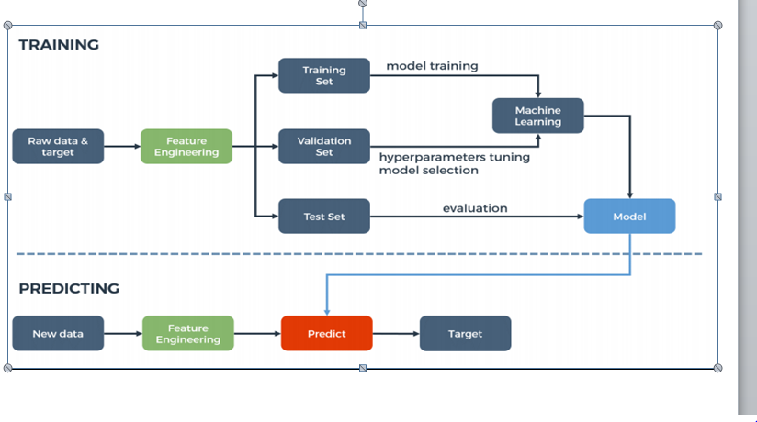

* **Hardware Software designing:**

Python based computer vision and knowledge about various machine learning algorithms and how to implement them. Knowledge of how to use ibm Watson studio for the deployment of the project.

**4. EXPERIMENTAL INVESTIGATIONS:**

* **Step 1:** Collection of data set from kaggle.

<https://www.kaggle.com/annetxu/health-insurance-cost-prediction>

* **Step 2:** On the IBM Watson studio platform use the auto AI to build a model that predicts the cost of the insurance that can be given customer based on the details given about the customer.
  1. For that first we need to create an account on the IBM Watson studio.
  2. Using add to project choose auto AI.
  3. Then upload the dataset that is taken from kaggle into the data assets

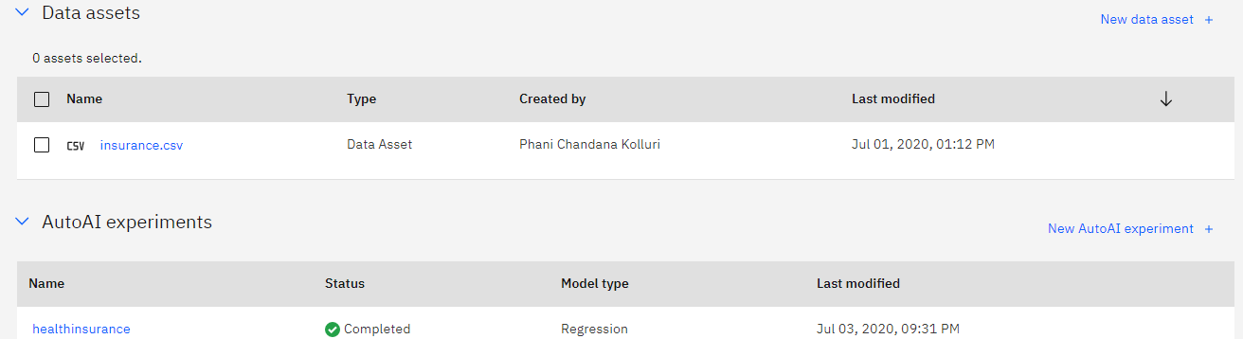

.

* 1. Choose the best machine learning model to predict the cost.
  2. Deploy the model.

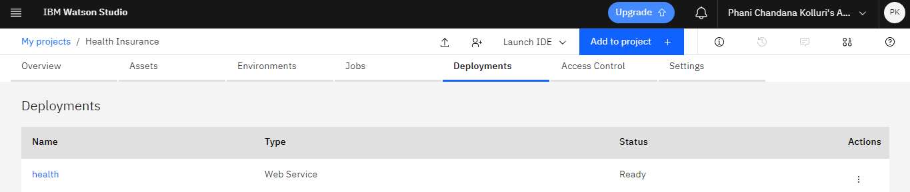

* 1. Test the model against various values.

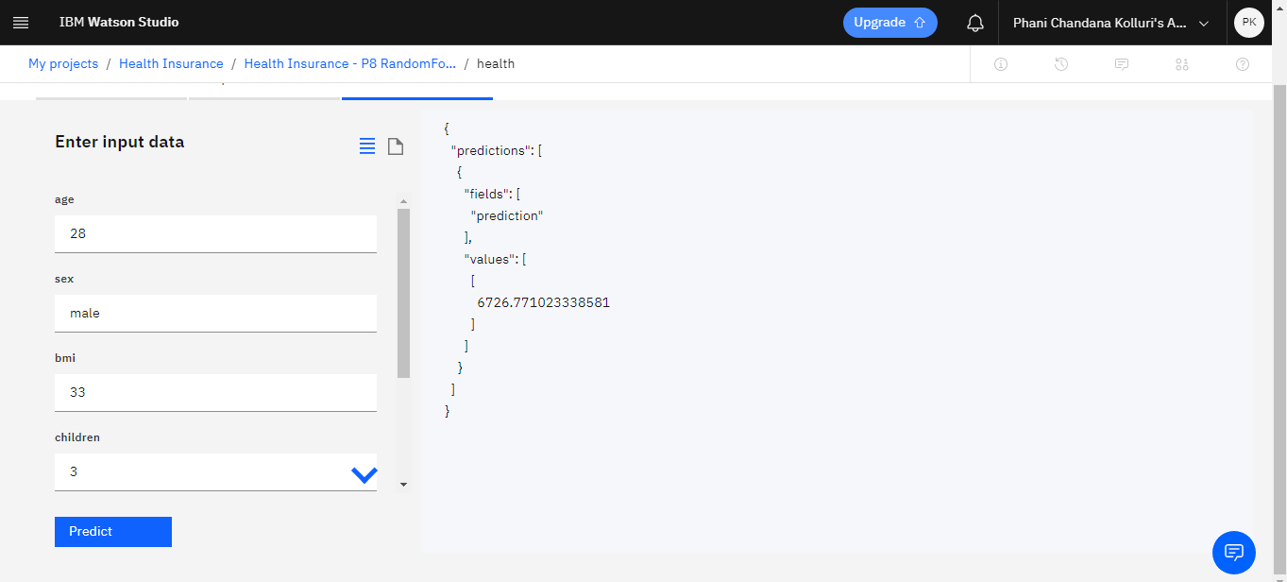

* 1. Then create a service credential and also cloud foundry app.

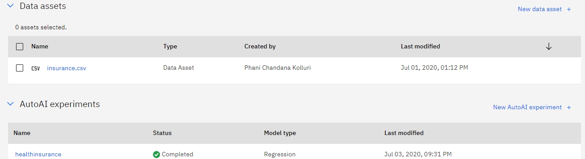

* 1. Make a node-RED flow.

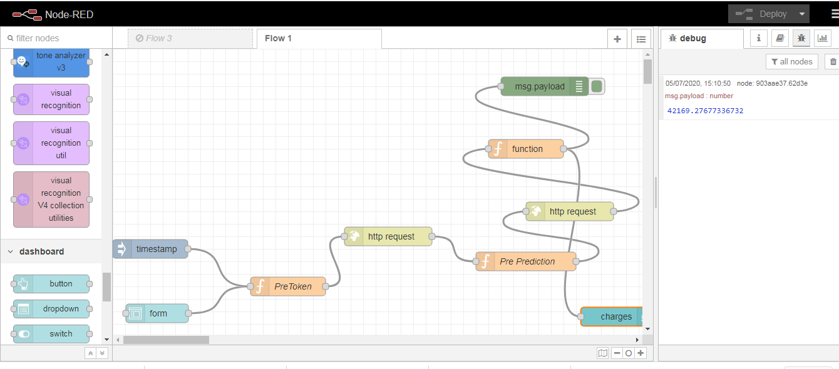

* 1. After the deployment of the model UI can be seen.

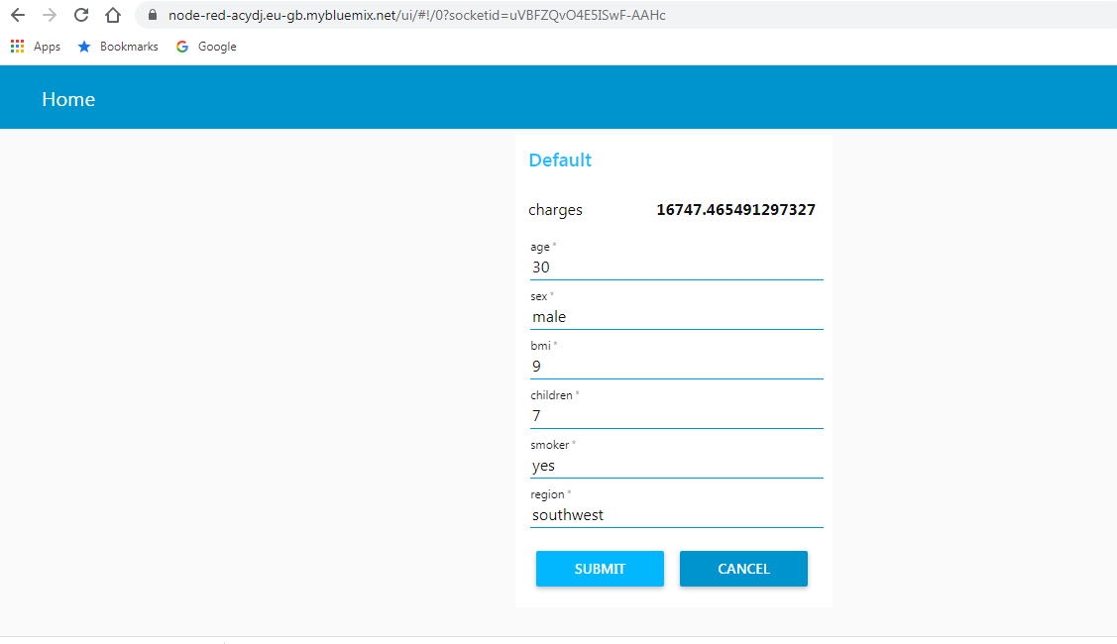

**5. FLOWCHART**



**6. RESULT:**

The machine learning model that works on the random forest algorithm predicts the cost of the health insurance package that can be given to a customer based on the details of the customers depending upon various factors.



**7. ADVANTAGES AND DISADVANTAGES:**

**ADVANTAGES:**

This model helps the health insurance companies to predict the cost of insurance that can be provided to a particular customer based on factors like age, gender, weight, previous health issues etc.

**DISADVANTAGES:**

Sometimes the cost requirment may not depend on gender, region they belong to.

**8. APPLICATIONS:**

This model that predicts the various health insurance policies applicable to a given customer can be used by the health insurance companies inorder to improvise their services and can also bring new changes to their policies based on the statistics.

**9. CONCLUSION:**

This was a great experience with Smartbridge learning new and interesting things and also applying them in innvoation field. Related to my project I can say that the machine learning model that is created to predict the cost of health insurance has a wide range of application and makes the work of health insurance companies more simpler. This gives all the predictions just by giving basic details of the customer.

I learnt a lot from this project and also thank all the mentors and the bootcamp that was very supportive and helpful at every point of work.

**10. FUTURE SCOPE:**

This can be implemented more efficiently by adding some more factors depending on which the model predicts the health insurance cost that can be provided.

**11. BIBLIOGRAPHY:**

* Kaggle for downloading the dataset.
* Smartbridge bootcamp to learn how to work on IBM Watson studio